Rationale and Guide
For
Expanded Age Group SIAs

Rationale and Guide for Expanded Age Group SIAs

Introduction
In 2012 the world saw the fewest number of polio cases in the fewest number of countries. However, in spite of the tremendous progress made in polio eradication in recent years, three countries remain endemic – Afghanistan, Nigeria and Pakistan. Until successful interruption of polio transmission in the endemic countries is achieved, considerable risk of outbreaks in polio free countries persists. Areas with suboptimal population immunity and where immunization services have been disrupted for a number of years are particularly at risk. In these settings older children and adults are likely to play a significant role in the transmission and spread of poliovirus within the country and across its borders. There is also a real risk that older children and adults in these areas will contract polio paralysis in substantial numbers, as observed in recent outbreaks (Republic of Congo 2010, Tajikistan 2010 and Namibia 2006).
The Global Polio Eradication Initiative (GPEI) recommends an immediate and effective response in case of a poliovirus outbreak. The outbreak response should aim to swiftly build population immunity, minimize the geographical scope and size of the outbreak, while simultaneously reducing the risk of spread to neighbouring countries.
One strategy to rapidly build population immunity and interrupt transmission is expanding the age group of individuals targeted for vaccination, known as expanded age group (EAG) supplementary immunization activities (SIA). EAG SIA includes vaccination of age groups: under 10, under 15, or all ages (i.e. the entire population). with oral polio vaccine (OPV).

This document describes the rationale for expanded age group campaigns. It also outlines when an EAG should be considered and provides basic principles for EAG planning and implementation.

Rationale for Expanded Age Group Campaigns
Specific reasons for conducting expanded age group polio immunization campaign in outbreak or endemic setting are as below:
Polio in higher age groups: While poliomyelitis mainly affects young underimmunized children, it can paralyze persons of any age, including adults, especially in settings where general population immunity is low. When adults are affected the results are devastating and often with a higher mortality rate. For example, when wild polio virus re-infected the Republic of the Congo in 2010-2011, almost 400 adults were paralyzed by polio in less than six months. Almost 50% of those affected died within days of contracting the virus.
Possible role of adults in spread of transmission - Waning of mucosal immunity over time: Gut or mucosal immunity prevents infection and further spread of poliovirus. Individuals with serum immunity against polio are protected from developing paralysis, but because of waning of the gut immunity over time they can still be infected by the poliovirus and are capable of infecting others, thereby facilitating the continued spread of the virus.
Several studies have shown that the intestinal mucosal immunity appears to wane significantly over time.
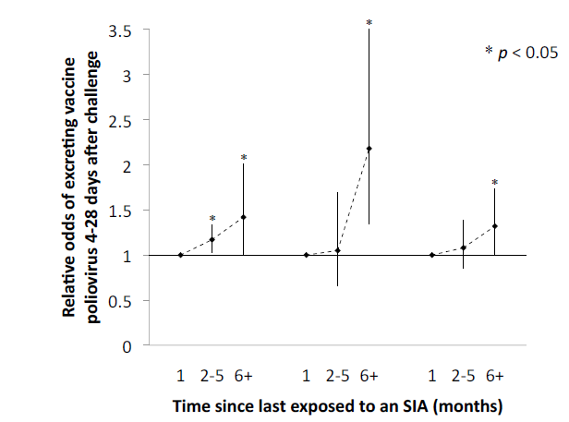
A study in India put forward that the odds of shedding poliovirus (for all three poliovirus serotypes) after a ‘challenge dose’ is significantly higher six or more months after the last OPV dose, compared with the first month after last OPV dose. The graph to the right shows the waning mucosal immunity for the three poliovirus serotypes 4-28 days after receiving the challenge dose.
PV 1 PV2 PV3

Data from Israel also suggest that mucosal immunity to poliovirus wanes over time. A significant decrease in intestinal immunity was observed one year after last contact with poliovirus, regardless of virus serotype.

Studies have also shown that older children participated in poliovirus transmission. Two investigations in India found that asymptomatic WPV infection was detected in individuals over the age of five (1-2% of healthy older children in infected areas excreted virus).The proportion and rate of asymptomatic WPV1 infections were similar among under five year olds and five to 15 year olds, but lower among the above 15 year olds.

Since persons with decreased or no gut immunity can play an important role in spreading polio virus even if they show no symptoms of disease, in the International Travel and Health guidelines WHO recommends primary polio immunization series according to the national immunization program, or at least one dose of polio vaccine for all adults and children who are traveling to or from a polio affected area (http://www.who.int/ith/en/ ).

The Kingdom of Saudi Arabia has strict vaccination requirements for any person travelling for Hajj from a polio infected area. Proof of polio vaccination is required before travel and an additional dose of polio vaccine is given upon arrival in Saudi Arabia for those traveling from a polio infected country, irrespective of age.

Impact of expanded age group campaign in outbreaks:
Dynamic models developed by the research organization Kid Risk has suggested multiple benefits for using expanded age group SIAs. In outbreak situations, the main benefit is shortening duration of outbreaks through reduction of WPV circulation and increase of overall population immunity.

The GPEI has recommended expanded age group vaccination campaigns in many countries including Namibia, Republic of the Congo, China, Chad, Tajikistan, Central African Republic, the Democratic Republic of Congo, Kenya and Somalia.

This experience from abovementioned countries has shown that conducting polio campaigns in expanded age groups can stop polio outbreaks faster and limit the spread of virus to other areas. In certain countries, like Namibia and Republic of the Congo, expanded age group vaccination campaigns were used to stop the intense polio transmission and paralytic disease in the adult population.

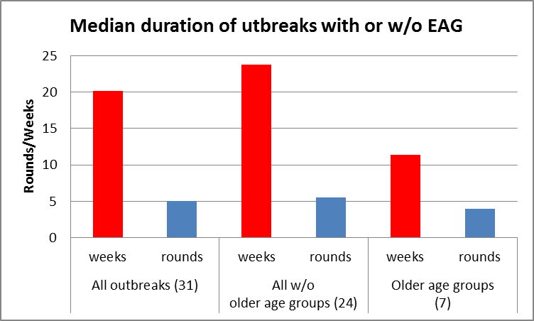
Experience from immunizing expanded age groups during polio outbreaks has shown that this strategy helps to shorten the length of the outbreak (11 against 24 weeks). The strategy is also seen to reduce the number of campaigns needed to stop an outbreak (5 against 7).

Contrary to initial concern, vaccination of older persons in an outbreak was shown to improve coverage among children younger under five years of age. In fact, more children under five, and especially under one, were vaccinated in expanded age SIAs because of more effective social mobilization and vaccinators not having to verify the age of children as everybody in the household/fixed point/mobile point were vaccinated.

When should the ‘Expanded age group campaign’ be considered?
If immunization services have been disrupted in many areas of a country for a number of years it is very likely that older children and adults in the country will play a significant role in transmission and spread of poliovirus within the country and across its borders. There is also a real risk that older children and adults in the country will contract polio paralysis in substantial numbers.
Expanded age group vaccination should be considered in areas with active wild poliovirus transmission or at immediate risk of importation when:
- Cases of paralytic poliomyelitis have been reported in persons over 5 years of age.
- Areas with significant immunity gaps that have persisted for an extended period of time (for example 60% routine coverage of U5s for 5-10 years and/ or poor reach of polio SIAs resulting in large sections of the <10 years old population being under immunized and at risk of contributing to WPV transmission)

Planning for expanded age group campaign:
The basic principles of planning and implementation of expanded age group SIA campaign remain same as that of SIA targeting <5 years children. However, the key in planning for expanded age campaign is to adapt micro-planning to reach the targeted age group wherever they are more likely to be present (for example targeting schools, markets, universities, factories etc).
Important considerations while planning for expanded age group campaigns:
- Microplanning:
  - Coverage in houses: Regular house to house vaccination to cover all persons within the target age group available in houses. Microplans for house to house teams should be modified to rationalize workload. This could be done by increasing the number of days of activity or increasing the number of teams or a combination of both. Workload: experience from other countries have shown that the optimum workload (number of children to be covered per day) for a house to house team is as below:
    - Under 10 years campaign - 1.5 times of <5 years campaign
    - Under 15 years campaign - 2 times of <5 years campaign
    - All ages campaign - 3 times of <5 years campaign

  - Fixed and mobile teams: Since in the majority in the above 5 age group is likely not to be present in households during morning hours, it is important to have extensive deployment of fixed (Transit) and mobile teams.
    - Coverage of population in movement: Fixed (Transit) teams should cover all busy place with population in movement (e.g. markets, hospitals, bus stands, railway stations and other transit points and places of congregation.) Higher number of teams should be deployed for first two days of activity as it is expected to have very high coverage during first two days.
    - Coverage of workplaces, schools, universities and other places with defined population: Mobile teams should be deployed to cover all sites with defined populations (e.g. factories, schools, institutions, hospitals, other workplaces etc.). Every site should be covered twice during campaign.

- Communication:
  - Social mobilization and communication: appropriate strategies to be developed to generate awareness and demand.
    - Extensive mass media campaign involving radio and newspapers to start ahead of campaign
    - Announcements in mosques, churches and establishments (e.g. factories, schools etc.)
    - Focused group meetings of mothers and youths.
  - A clear communication strategy should be developed for anticipated concerns such as absence of risk for pregnant women, alcohol use, CAT consumption, any contraindication, etc.
  - Ahead of campaign start: Before the campaign starts, a competent and respected individual equipped with a letter from the authority, information leaflets and posters should visit all establishments (large companies, schools, market committees, religious places etc.). The person should:
    - Inform of campaign and agree for teams arrive;
    - Identify location and timings of booths for planning; and,
    - Ask management/locals to facilitate the work of teams (i.e. help with staff awareness, visible and manageable sites, tables, umbrellas, etc.)
  - Interpersonal Communication (IPC) by house to house mobilizers at least in high risk areas.
  - Launch one day before actual start targeting high profile adult population group. This will have good impact on communication.

- Finger marking:
  - Remains same as that for SIA targeting under 5.
  - Left little finger should be marked for all persons vaccinated during the campaign.
  - Older persons may show reluctance for finger marking while accepting vaccination. This fact should be kept in mind while designing monitoring strategy.

- House marking:
  - Remains the same as that for SIA targeting under 5.
  - House marking can be simplified to include only date of vaccination and whether all eligible beneficiaries have been vaccinated.

- Composition of vaccination teams:
  - House to House teams: Same as for SIA targeting under 5, should have two vaccinators. Each team should preferably have at least one local, female vaccinator from same community.
  - Fixed (transit) teams: Should have two vaccinators and one mobilizer. Busy transit points will need more than one fixed team depending on the workload.
  - Mobile teams: Mobile teams should have two vaccinators who are familiar with the area and capable to talk to concerned authorities of establishments.

- Recording and Reporting:
  - Reporting of vaccination coverage should have information on children <5 years covered during expanded age campaign.
  - Tally sheets and reporting format should be modified to include expanded age and capture information in different age category i.e. less than 5 and more than 5

- Vaccine and Logistics:
  - Vaccine requirement: Overall, there will be 3 times the vaccine requirement for <15 SIA and 6 times for all age SIA, compared with <5 SIA
  - Expected vaccine requirement per day by different teams should be calculated on the basis of target.
  - The teams should be given around 100% additional doses to expected target on first and second day of campaign. In expanded age group campaigns, coverage on initial days is much higher than expected target as there usually is high demand both during house to house, as well as for fixed and mobile team activity.
  - Fixed (transit) teams deployed at markets and other busy places will need 500 to 1000 doses per day for initial two days of activity
  - A strong system for vaccine and logistic flow including provision of quick replenishment should be planned.
  - Every team must be given sufficient finger marker pens; numbers calculated on basis of 1 marker pen for every 400 children to be covered, rounded up to higher level. Every vaccination teams should have at least two finger marker pens.
  - Cold chain capacity should be reassessed and strengthened in view of increased vaccine requirements.

- Monitoring
  - Monitoring tools:
    - Should be simplified to focus only on coverage and basic information.
    - Should be modified to include information on coverage by age group
(<5 years and >5 years)
  - Monitoring process should focus equally on ‘in house’ assessment as well ‘out of house sites’ assessment of coverage.

- Training of vaccinators on new changes related to expanded age group
  - Expanded age group campaigns is different from SIA targeting <5 in the terms of microplanning, recording/ reporting and also expected queries from beneficiaries.
  - Hence, all vaccinators should be trained regarding the changes in microplan, procedures etc. and capacity to satisfactorily answer queries of beneficiaries (for example, reasons why adults are vaccinated).
Operational coordination structures should be established at all levels with clear timeline, priorities and responsibilities.

Budgeting considerations:
- Target population: Target population of under 10 is usually taken as two times of under 5 campaign. For under 15 campaign it is three times and for all age campaign it is taken as 5 times.
- Budgeting should be done on the basis of Microplanning process for house to house team, Fixed teams and mobile teams as described in earlier section.
  - Increase in number of house to house teams or number of days of activity or both
  - Increase in fixed and mobile teams
- Number of supervisors or supervisor days are calculated in proportion to increase in teams.
- Other logistic requirements like vehicle days are modified accordingly.

Grassly NC, Jafari H, Bahl S, et al. Waning intestinal immunity after vaccination with oral poliovirus vaccines in India. J Infect Dis 2012; 205:1554-61.
Intestinal immunity following a combined enhanced inactivated polio vaccine/oral polio vaccine programme in Israel. Swartz TA, Green MS, Handscher R, Sofer D, Cohen-Dar M, Shohat T, Habib S, Barak E, Dror Z, Somekh E, Peled-Leviathan T, Yulzari R, Libling A, Mendelson E, Shulman LM. Vaccine. 2008 Feb 20;26(8):1083-90. doi: 10.1016/j.vaccine.2007.12.021. Epub 2008 Jan 7.
Enhanced Poliovirus Surveillance among >5 year-old persons in Uttar Pradesh (July – October 2009).
Community Investigation for Wild Polio Viruses, Saharsa, Bihar (July 2009).
Duintjer Tebbens RJ, Pallansch MA, Chumakov KM, et al. Expert review on poliovirus immunity and transmission. Risk Anal 2013; 33:544-605.
Duintjer Tebbens RJ, Pallansch MA, Chumakov KM, et al. Review and assessment of poliovirus immunity and transmission: synthesis of knowledge gaps and identification of research needs. Risk Anal 2013; 33:606-46.
Thompson KM, Pallansch MA, Tebbens RJ, Wassilak SG, Cochi. Modeling population immunity to support efforts to end the transmission of live polioviruses. Risk Anal. 2013 Apr;33(4):647-63. doi: 10.1111/j.1539-6924.2012.01891.x. Epub 2012 Sep 17.

